EXP 17: CHANGE HARDWARE COMPATIBILITY OF A VM (EITHER BY CLONE/CREATE NEW ONE) WHICH IS ALREADY CREATED AND CONFIGURED.
DATE:
AIM: To Change Hardware compatibility of a VM (Either by clone/create new one) which is already created and configured.
PROCEDURE:
STEP 1:GOTO VM WARE WORKSTATION.
STEP2: RIGHT CLICK THE VM AND GOTO THE SETTINGS.
STEP 3: ADD HARDWARE WIZARD AND SELECT SCSI AND CLICK NEXT.
STEP 4: CREATE NEW VIRTUAL DISK.
STEP 5: SELCT THE DISK SIZE AS 2.0. AND SELCT SPLIT VIRTUAL DISK INTOMULTIFILES.
STEP 6: GIVE NAME AND CLICK THE FINISH.
DESIGN:
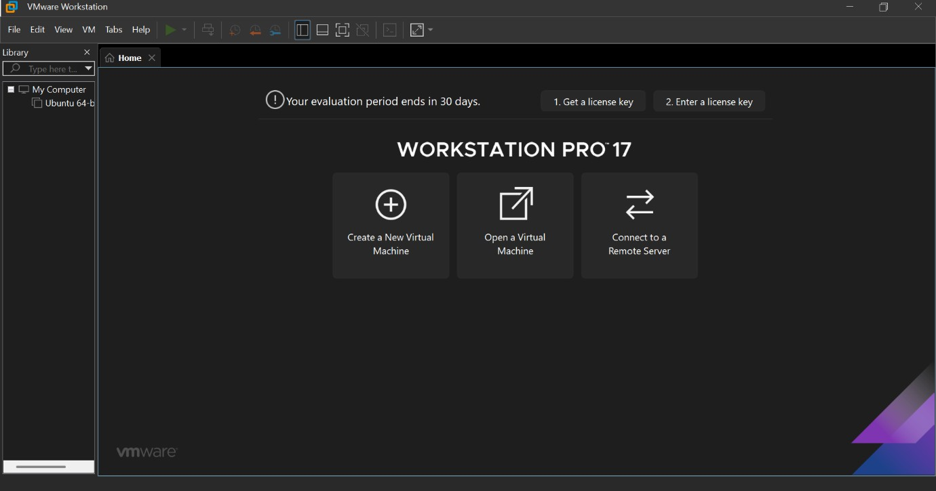
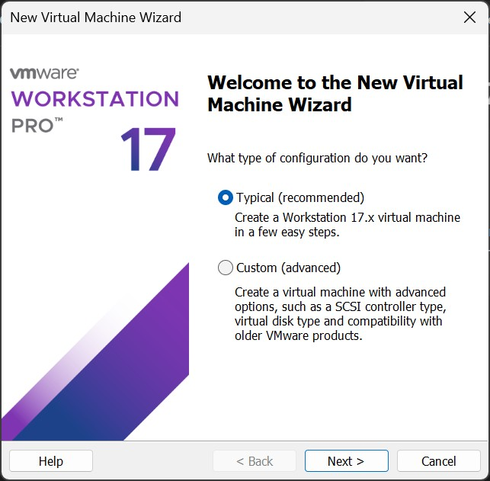

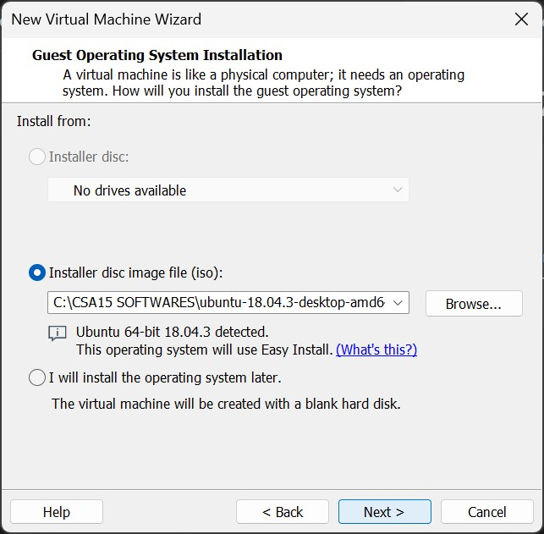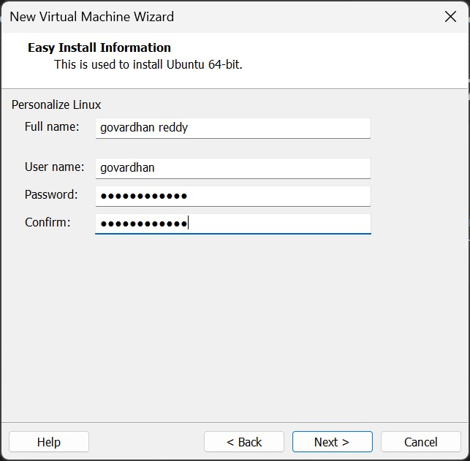

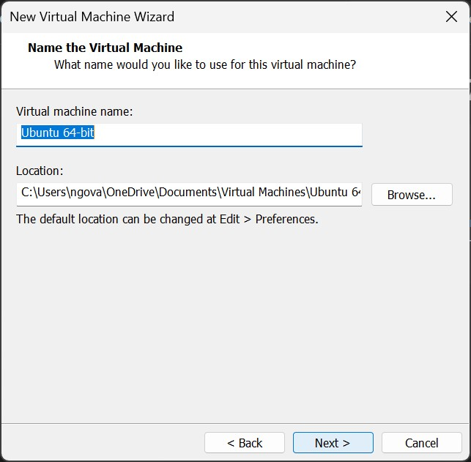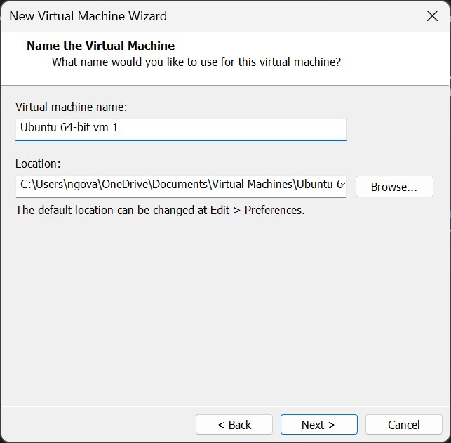
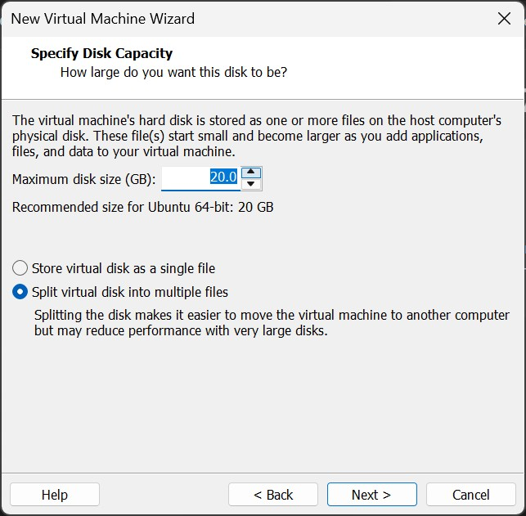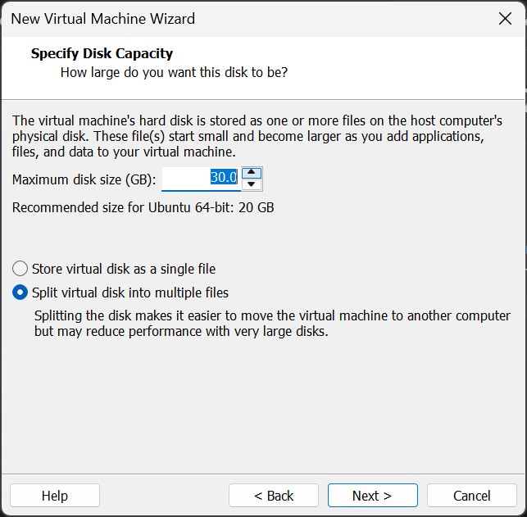
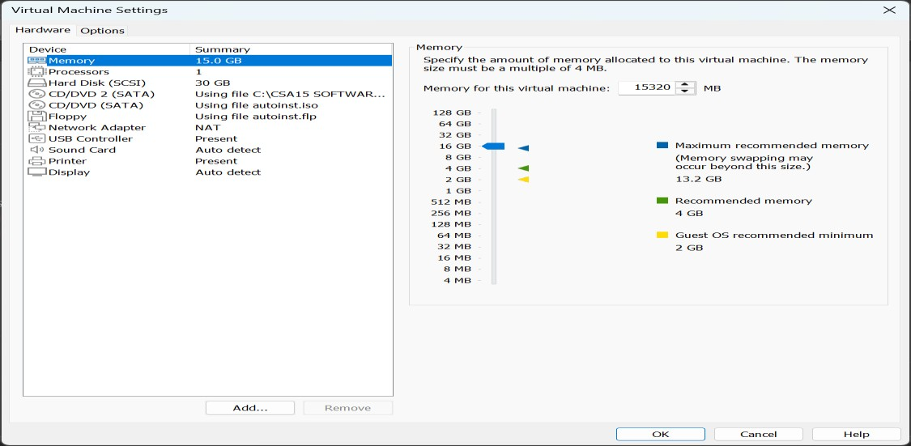
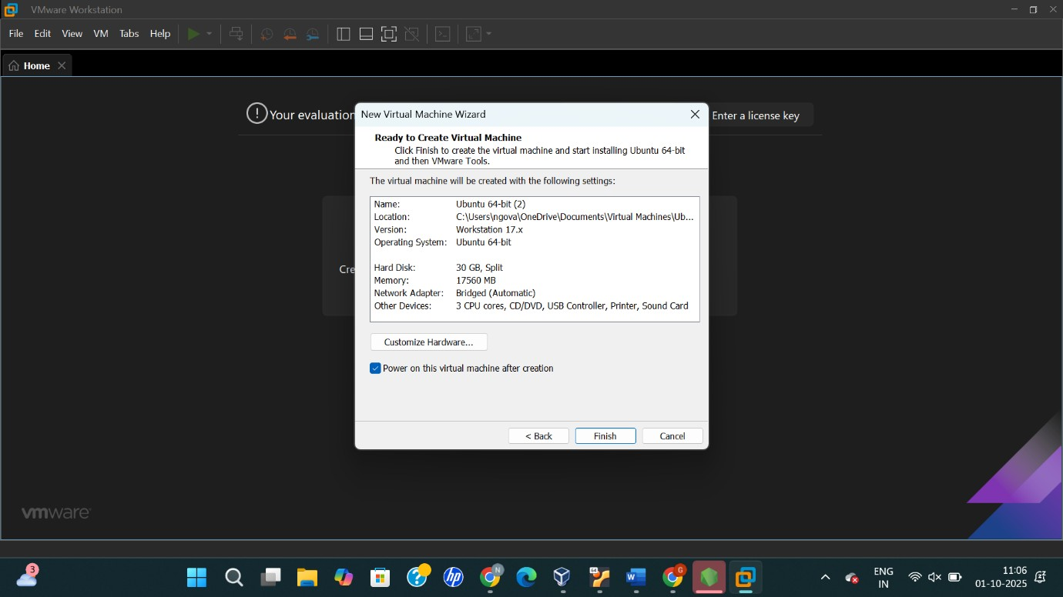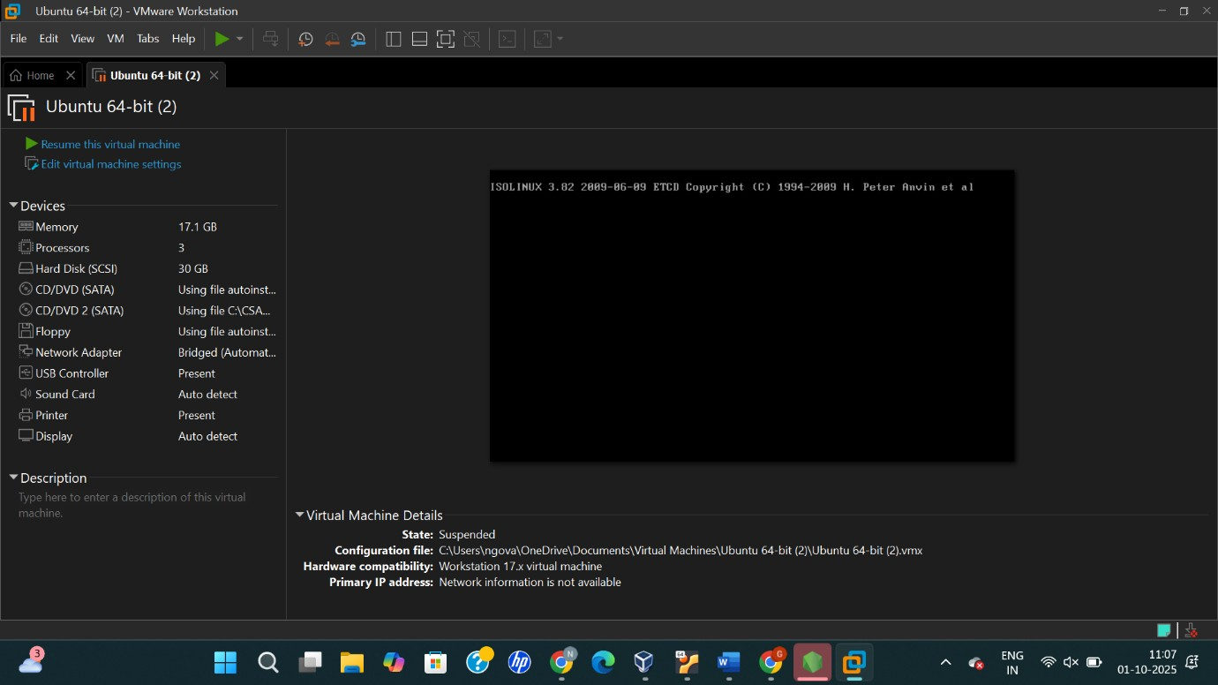
RESULT :
Sucessfully changed hardware compatibility of a vm (either by clone/create new one) which is already created and configured.

